

**[Session 2 Assignments]**

[TechKids]

January 30, 2019

Tran Viet Hoang

Max-

0833546468

Number Page: 4

Contents

1 What is Boolean? Write down 3 different expression that results a Boolean type (i.e. 5 == 6) 2

1.1 Definition 2

1.2 Example 2

2 What is a flow chart? Draw flow chart for the following code snippet: (you can draw on a paper, take a picture of it) 2

2.1 Definition 2

2.2 Flow Chart 2

3 What are nested conditionals? Write a piece of code that uses nested conditionals 3

3.1 Definition 3

3.2 Example 3

# What is Boolean? Write down 3 different expression that results a Boolean type (i.e. 5 == 6)

## Definition

Boolean is a binary variable and two possible values called “true” and “false”.

## Example

+> 5 == 6 => False

+> 4 == 2+2 => True

+> 5 - 1 != 6 - 2 => False

# What is a flow chart? Draw flow chart for the following code snippet: (you can draw on a paper, take a picture of it)



## Definition

It is a type of diagram that represents the flow of execution of the program

## Flow Chart

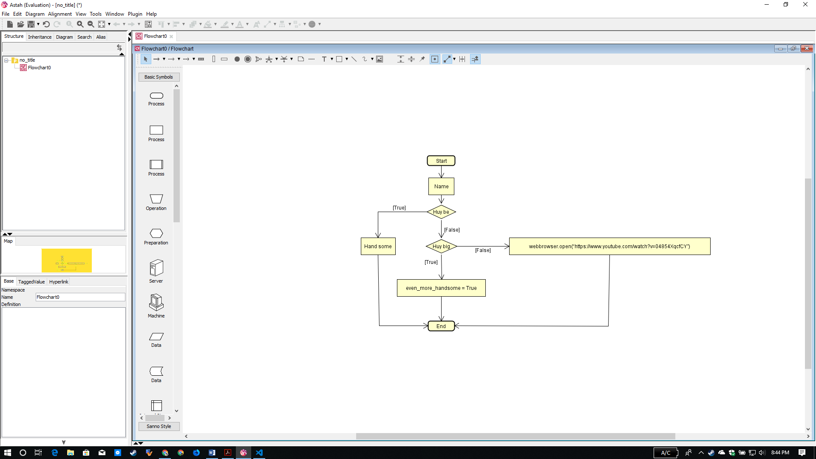

# What are nested conditionals? Write a piece of code that uses nested conditionals

## Definition

Nested conditions comprise condition statements contained within the definition of other conditional statements



## Example

if do_assignment == 'done':

print('take a rest and go out have some fun')

else:

if do_assignment == 'doing':

print('then why you stop?')

else:

print('do it now sir!')